Lab Report 4: Mesh Analysis Methods

Mesh Analysis and Circuit Verification

Mesh Analysis and Circuit Verification
The method for calculating loop currents and branch voltages in the circuit was verified using mesh analysis. This technique operates by applying Kirchhoff’s Voltage Law (KVL) around each closed loop (or "mesh") within the circuit. Instead of solving for node potentials, we define mesh currents for each window-like loop and write equations representing the sum of voltages around those paths.
By expressing the voltage drop across each resistor as the product of the resistance and the net mesh current passing through it we generate a system of linear equations. Solving this system allows us to determine the individual mesh currents, which can then be used to find any branch current or component voltage drop. This method is particularly efficient for planar circuits and provides a direct way to compare theoretical loop behavior with experimental measurements taken in the lab
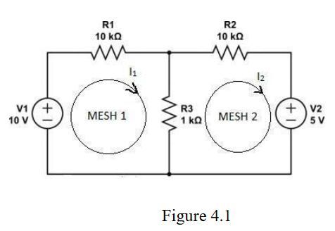
The circuit being analyzed

The theoretical results were calculated by hand and simulated in Circuit Lab
For the hand calculated results:
- $I_{2}$ in terms of $I_{1}, R_{2}, R_{3}$. $I_{1}$ gets absorbed in when solving for $I_{2}$. The hand calculations are in the next page.
$$I_{2}=\frac{\left(10\frac{R_{3}}{R_{2}+R_{3}}-5\right)}{\left(-\frac{R_{3}^{2}}{R_{2}+R_{3}}+\left(R_{2}+R_{3}\right)\right)}=-375 μ\text{A}$$
- Current values for $I_{1}$ and $I_{2}$
$$I_{1}=\frac{I_{2}R_{3}+10}{R_{2}+R_{3}}=875 μ\text{A}$$
Matrix operations can also be used.
$Let \text{col 1}$ be $I_{1}$ and $\text{col 2}$ be $I_{2}$, solving the system equations using matrix operations:
$$\left[\begin{matrix}\left(R_{1}+R_{3}\right) & -R_{3} & 10 \\ -R_{3} & \left(R_{2}+R_{3}\right) & -5\end{matrix}\right]=\left[\begin{matrix}11 \text{kΩ} & -1 \text{kΩ} & 10 \\ -1 \text{kΩ} & 11 \text{kΩ} & -5\end{matrix}\right]\underset{⇒}{\text{rref}}\left[\begin{matrix}1 & 0 & 875 \text{μA} \\ 0 & 1 & -375 \text{μA}\end{matrix}\right]$$

For the Circuit Lab Results:
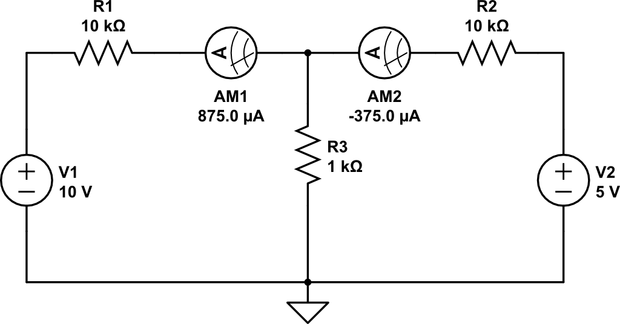

Experimental Results
The results for the experiment are in the table below

$$I_{1}$$ | $$882 μ\text{A}$$
$$I_{2}$$ | $$-382.1 μ\text{A}$$

The results closely match to the theoretical values. Discrepancy in values are due to resistor tolerances.
Therefore, mesh analysis is verified.

Nodal vs Mesh
Nodal analysis is most efficient for circuits with fewer nodes than loops or those containing many parallel branches and voltage sources; it is also the only option for non-planar circuits. Conversely, mesh analysis is preferred for planar circuits with fewer loops than nodes or those with many series components and current sources. Ultimately, the best method is the one that aligns with the specific circuit characteristics to simplify the mathematical complexity.

Mesh Analysis with Current-Dependent Voltage Source

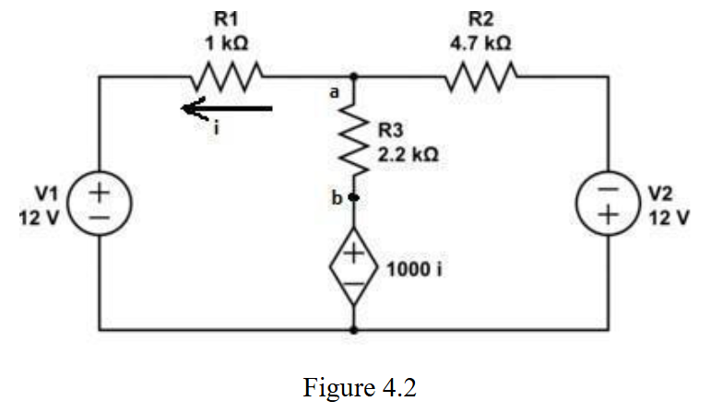
When we keep the original direction of $i$, but flip the polarity of the current-dependent voltage source $1000i$ we get
$$\left[\begin{matrix}4200 & -2200 & 12 \\ -3200 & 6900 & 12\end{matrix}\right]\underset{⇒}{\text{rref}}\left[\begin{matrix}1 & 0 & 4.977 \text{mA} \\ 0 & 1 & 4.047 \text{mA}\end{matrix}\right]$$

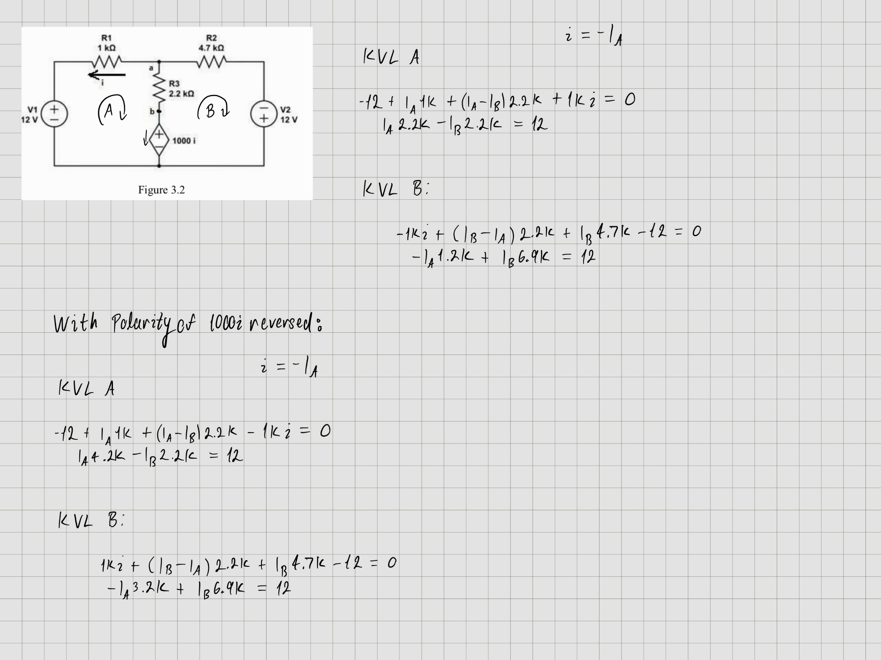
Which matches with the simulations
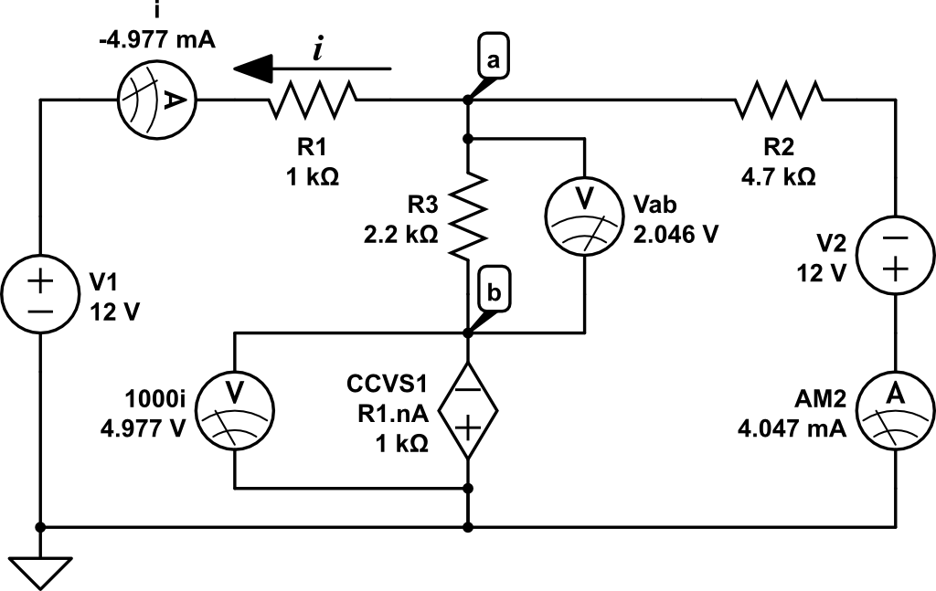

This closely matched our experimental data
$$i$$ | $$-5.083 \text{mA}$$
$$1000i$$ | $$5 \text{V}$$
$$V_{ab}$$ | $$1.964 \text{V}$$

Therefore changing the polarity of the CCVS modifies the KVL mesh equations and changes the magnitude of the current $i$.

